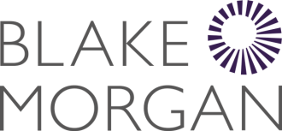
Access to Work Guide for Applicants: Communication Support at Interview

Effective Date: 1 February 2024
Last updated: 1 February 2024
Our EDI policy

Equality, Diversity and Inclusion Policy
Blake Morgan is committed to promoting the principles of equality, diversity and inclusion by identifying the different needs and development objectives of individual colleagues and helping them to fulfil their potential.
It is our belief that differences represent opportunities rather than problems, and we seek and welcome the insights and views of diverse groups.
Click on the link below for highlights of the activity that took place across Blake Morgan in the 2022/23 financial year to support our communities.
https://publications.blakemorgan.co.uk/chair-annual-report/cover

Introduction

You can apply to Access to Work to get money for communication support at a job interview.
The money pays for a communication support worker to go to your job interview with you.
You can use this service if you:
- are Deaf or hard of hearing and need a British Sign Language interpreter or lipspeaker
- have a physical or mental health condition or learning difficulty and need communication support
You need to apply before the interview takes place and tell Access to Work the total cost of the communication support you’ll need.
For help with finding communication support and getting costs, you can contact your employment adviser or an organisation that specialises in supporting people with your needs.
Access to Work pay the costs after the job interview has taken place.
The money does not have to be paid back and will not affect your other benefits.

Eligibility

To get communication support at a job interview you must:
- have a health condition or disability which means you need communication support at job interviews
- have an interview date for a paid job or apprenticeship in England, Scotland or Wales, or a Department for Education supported internship

When you cannot apply
You cannot apply if:
- your job interview has already taken place
- the interview is for a volunteer role
- you’re attending a job induction or job review

How to apply

Check if you’re eligible before you apply. You can apply online or by phone.

What you’ll need to provide
You’ll need to tell Access to Work:
- the name of the company your job interview is with
- the date of your job interview
- how long your job interview is expected to last
- the name and contact details for someone at the company – Access to Work will only contact this person after your job interview to confirm it has taken place

You’ll also need to tell Access to Work the total cost of your communication support at the job interview. Ask the person providing your support to include:
- support worker costs
- support worker travel costs
- administration costs
- VAT

Apply by phone
You can apply by calling the Access to Work helpline. Make sure you have all the necessary details with you when you call.

Access to Work helpline:
Telephone: 0800 121 7479
Textphone: 0800 121 7579
Relay UK (if you cannot hear or speak on the phone): 18001 then 0800 121 7479
Monday to Friday, 9am to 5pm
Find out about call charges

British Sign Language (BSL) video relay service
To use this you must:
- first check you can use the service
- go to the video relay service
Monday to Friday, 8am to 7:30pm

Alternative formats
Call the Access to Work number to ask for alternative formats, such as braille, large print or audio CD.

Step by step guide for online applications

Click on the link below and follow the steps.
https://www.get-disability-work-support.service.gov.uk/csi/have-total-cost?lang=en

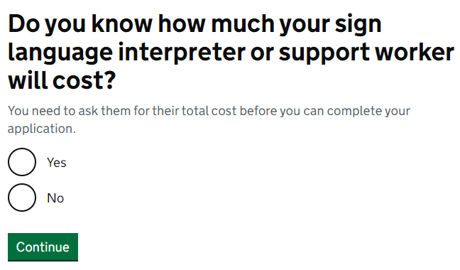

If you select No:
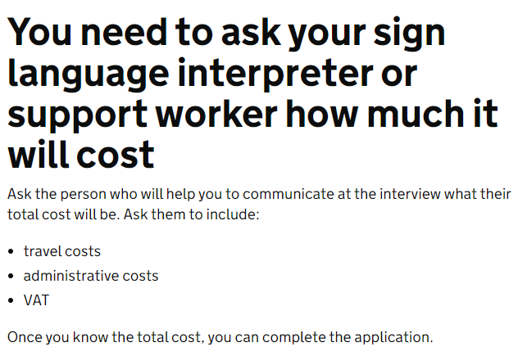

1. Personal details

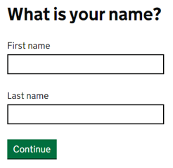

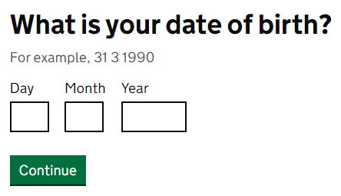

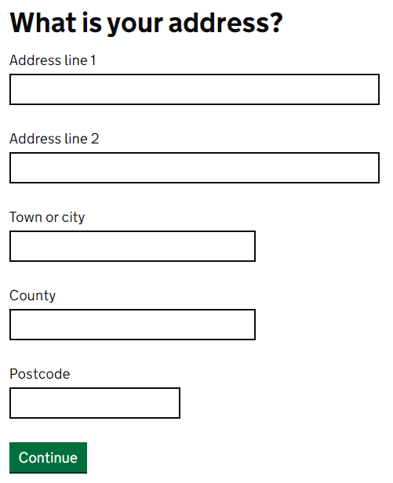
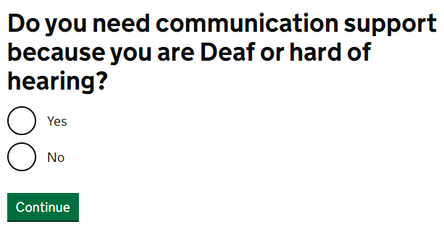

If you select No:
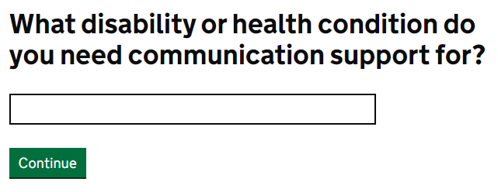

2. Your job interview

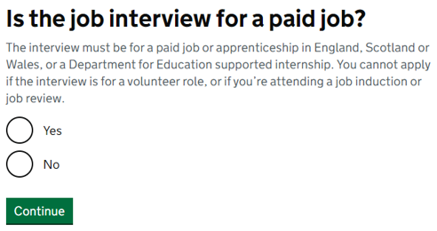

If you select No:
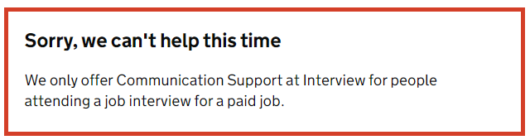

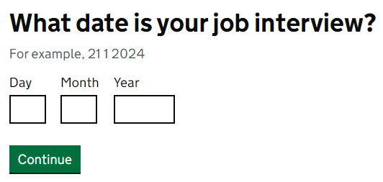

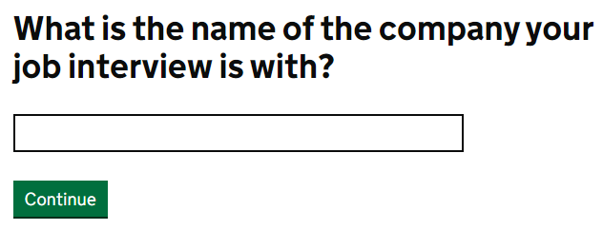
Type Blake Morgan LLP.

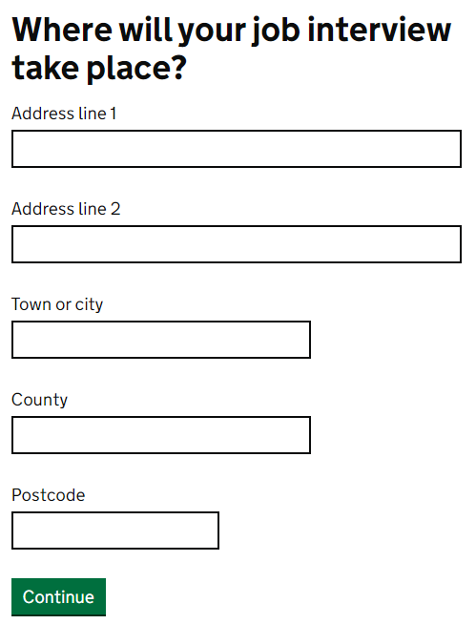

Refer to the list of Blake Morgan addresses below:
Cardiff: One Central Square, Cardiff CF10 1FS
London: 6 New Street Square, London EC4A 3DJ
Oxford: Seacourt Tower, Westway, Oxford OX2 0FB
Reading: Apex Plaza, Forbury Road, Reading RG1 1AX
Southampton: New Kings Court, Tollgate, Chandler’s Ford, Eastleigh SO53 3LG

If your job interview is being held virtually (Microsoft Teams for example), please enter the address of the Blake Morgan office where you will be based should you be offered the job you have applied for.

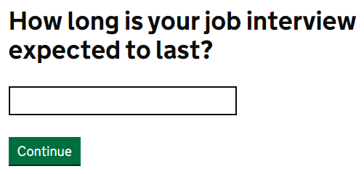

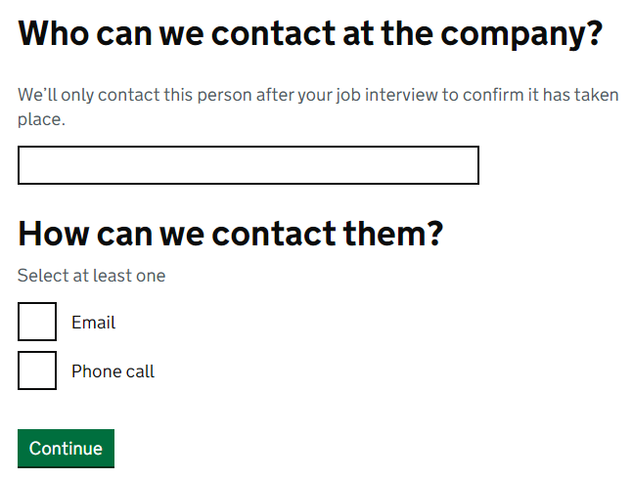
Should Blake Morgan receive sensitive personal information regarding your application for Access to Work, this information will be treated in the strictest of confidentiality.

2. Your support

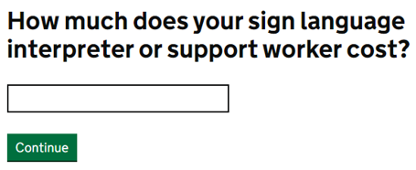

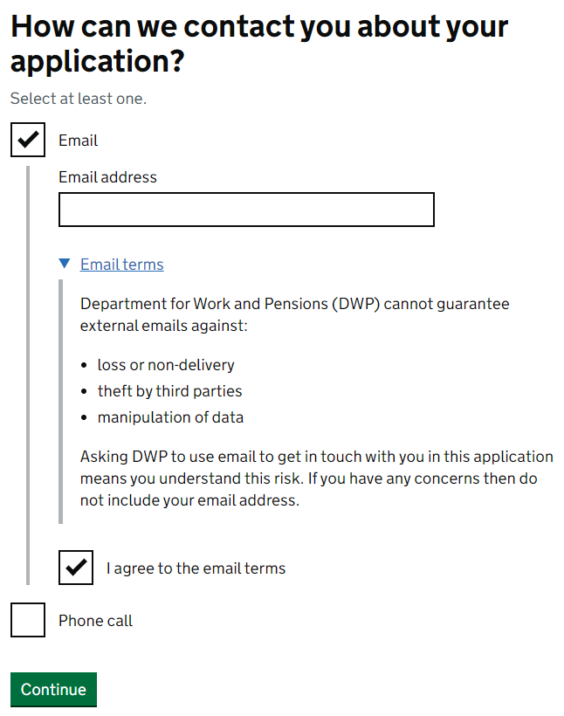
Check your answers on the following page. If everything is correct, click on Accept and Send.

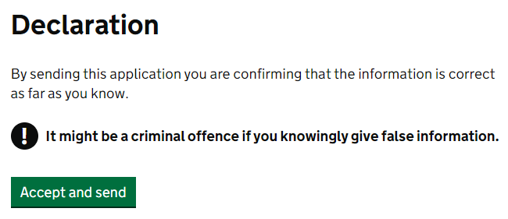

.

After you’ve applied

- An adviser will tell you the decision, using your preferred contact method, within 2 working days. Access to Work will post you confirmation and a claim form.
- Once Access to Work have agreed to pay for your communication support, you can book your support worker for the job interview, if you haven’t already.
- When your job interview has taken place, payment can be claimed. This needs to include the invoice. You’ll need to sign the claim form to confirm it’s okay.
- Access to Work will pay the claim if the invoice cost matches the cost you told them when you applied.

CARDIFF
T: 029 2068 6000
F: 029 2068 6380
LONDON
T: 020 7405 2000
F: 0844 620 0402
OXFORD
T: 01865 248 607
F: 0844 620 3404
READING
T: 0118 955 3000
F: 0118 955 3210

www.blakemorgan.co.uk
SOUTHAMPTON
T: 023 8090 8090
F: 0844 620 3401

info@blakemorgan.co.uk

